Options
- el: string | HTMLElement
Parent element of widget
- tableStyle?: TtgWidgets.Components.Table.Style
Style of table. Current options: "lowlight" | "lowlight-even-odd"
- switchStyle?: TtgWidgets.Components.Switch.Style
Style of switch. Current options: "primary" | "bordered-primary" | "underlined-primary"
- tabs?: Array<TtgWidgets.Leaderboard.Types.NavigationTab>
Array of tab options.
  - Bets:
Displays live bets data.
    - type: “bets”
    - title: string
  - Big Wins:
Displays bets higher or same as defined multiplier.
    - type: “bigWins”
    - title: string
    - multiplier: number
  - Races:
Displays tournament data (leaderboard and live points update). First tournament with label “RACE” and status ACTIVE or PENDING is selected. If a tournament does not exist, the tab is hidden. Additionally id parameter can be included to display wanted tournament instance.
    - type: “races”
    - id?: string
- limit?: TtgWidgets.Leaderboard.Types.Limit
Limit selector settings
  - options: Array<number>
  - default: number
- emojis?: TtgWidgets.Leaderboard.Types.Emojis
Displays custom emojis for win / bet multiplier.
Can be array of emoji config:
  - m1: number
Show emoji if multiplier >= m1
  - m2: number
show emoji if multiplier < m2
  - count: number
max repeated emojis for single bet. eg:
m1=0, m2=10, count=3, emoji=x
mul - 1 - x
mul - 5 - xx
mul - 9 - xxx
  - emoji: string
Or emoji getter function:
(mul: number) => string

Initialization example
factory.fetch("leaderboard").then((Widget) => {
new Widget({
el: "leaderboard-el",
tableStyle: "lowlight-even-odd",
switchStyle: "bordered-primary",
tabs: [
{ type: "bets", title: "Bets" },
{ type: "bigWins", title: "Big Wins x10", multiplier: 10 },
{ type: "races", title: "Races" }
],
limit: {
default: 10,
options: [5, 10, 20]
},
emojis: [
{ m1: 1, m2: 2, count: 1, emoji: ":(" },
{ m1: 2, m2: 20, count: 10, emoji: ":)" }
]
})
})

Views

Bets
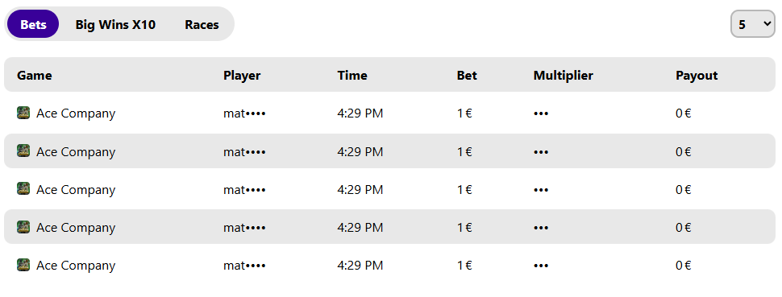

Big Wins
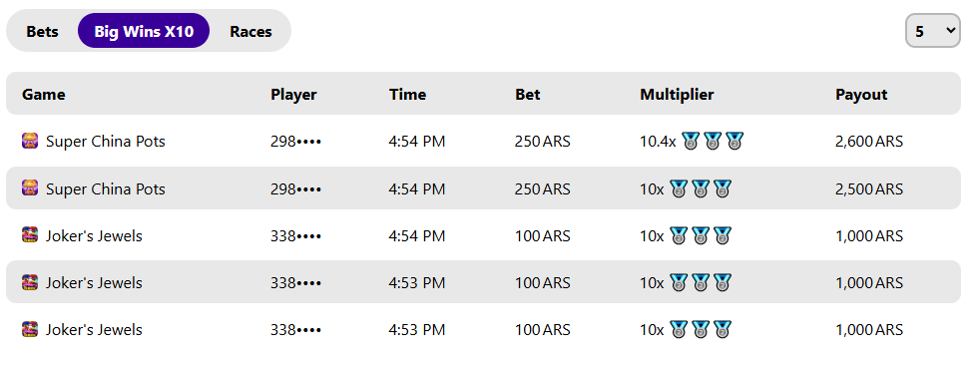

Races
